
Birchfield Independent Girls School
POLICY FOR E-SAFETY AND INTERNET ACCESS
THE USE OF COMPUTERS, INTERNET AND ELECTRONIC MAIL

The Prophet sallaa Allaahu aliahe wa sallam said:

“Obedience (to somebody) is required when he enjoins what is good.”

Saheeh Al Bukhari

Introduction

Birchfield Independent Girl’s School will allow all their pupils, teachers and other employees and volunteers access to utilise their ICT equipment, computers, and the internet.

All pupil activity, when using the network and internet in school, must be in support of their education and for research, and must be appropriate to the educational objectives of the school. Pupils who access the internet from school are responsible for their activities and these are logged. The exchange of data, ideas, social interaction and learning opportunities involved are greatly beneficial to all but can occasionally place our pupils and staff in danger.

E-safety covers issues relating to children and young people as well as adults and their safe use of the Internet, mobile phones, and other electronic communications technologies, both in and out of school. It includes education for all members of the school community on risks and responsibilities and is part of the ‘duty of care’ which applies to everyone working with children.

Birchfield Independent Girls School places the safety of their staff and pupils at paramount importance. We also are aware of the importance of ICT in our pupils’ learning and development both in and out of school.

It is important to us that our girls develop and enjoy themselves and make the most of their time here with us, making maximum use of the ICT facilities available. We want our girls to acknowledge that they completely safe using the Internet at the school and that they are not vulnerable to any dangers or abuse, whether it involve cyber-bullying or communications with strangers.

We exercise a balance between controlling access to the internet and technology, setting rules and boundaries and educating pupils and staff about responsible use. We empower and educate our pupils and staff so that they are equipped with the skills to make safe and responsible decisions, as well as to feel able to report any concerns. Our staff are aware of the importance of good E-safety practice in the classroom. They are also informed about how to manage their own professional reputation online and demonstrate appropriate online behaviours compatible with their role.

Benefits

Access to e-mail and the internet will enable staff and pupils to:

- Explore thousands of libraries, databases, museums, and other repositories of information
- Exchange personal communication with other Internet users around the world
- Be included in government initiatives and global educational projects
- Keep abreast of news and current events
- Take part in live discussion with experts
- Publish and display work by creating personal web pages

Effective Use

Internet access will be planned to enrich and extend learning activities as an integral aspect of the curriculum. Pupils will:

- Be given clear objectives of Internet use
- Be educated in responsible and effective Internet use
- Be supervised appropriately
- Learn to search for and discriminate between valid and inappropriate material
- Learn to copy, save, and use material found on the Internet without infringing copyright

Safety

Internet access at Birchfield Independent Girls School is controlled, i.e., a filter is used to stop the viewing of unsuitable websites. However, and ultimately, parents and guardians of minors are responsible for setting and conveying the standards that their pupils will follow when using media and information sources. We also have filtering on the internet provided and Net Support DNA safeguarding controls which are maintained by the school’s technician. This provides additional customisable filtering; allowing pupils to only view web pages that have not been identified as inappropriate. All web activity is logged, and pupil activity is monitored.

All staff are made aware of the potential risks of using social networking sites or personal publishing either professionally with students or personally.

They will be aware of the importance of considering the material they post, ensuring profiles are secured and how publishing unsuitable material may affect their professional status. Civil, legal, or disciplinary action could be taken if they are found to bring the profession or institution into disrepute, or if something is felt to have undermined confidence in their professional abilities.

Examples of social media and personal publishing tools include blogs, wikis, social networking, forums, bulletin boards, all types of online gaming, chat rooms, instant messenger, and many others.

- The school will control access to social media and social networking sites.
- Pupils will be advised never to give out personal details of any kind which may identify them and/or their location. Examples would include real name, address, mobile or landline phone numbers, school attended, IM and email addresses, full names of friends/family, specific interests etc.
- Staff wishing to use social media tools with students as part of the curriculum will risk assess the sites before use and check the sites terms and conditions to ensure the site is age appropriate.
- Pupils will be advised on security and privacy online and will be encouraged to set passwords, deny access to unknown individuals and to block unwanted communications.
- Pupil will be encouraged to approve and invite known friends only on social networking sites and to deny access to others by making profiles private.
- All members of the school community are advised not to publish specific and detailed private thoughts, especially those that may be considered threatening, hurtful, or defamatory.
- Concerns regarding students’ use of social networking, social media, and personal publishing sites (out of school) will be raised with their parents/carers, particularly when concerning students’ underage use of sites.

Personal Security Guidelines

Pupils will:

- Never reveal personal information over the internet, whether their own or another’s home address, telephone numbers or/and personal email address.
- Not use personal or photographs of themselves on their web pages unless the parent or guardian has granted permission.
- Never meet people in person that they have contacted via the internet without parent / guardian permission and/or supervision.
- Notify their teacher whenever they come across information or receive messages that are dangerous, inappropriate, or make them feel uncomfortable.
- Be aware that the author of an email or web page may not be the person they claim to be.

School and Personal Web Pages

Pupils are encouraged to take an active role in writing web pages. This often inspires pupils to publish work to a high standard for a wide and varied audience. Web pages can be used to:

- Document curricular research
- Be part of an online project
- Promote activities the school and community
- Publish resources for projects and homework
- Create personal pages detailing interests and displays of work

Access Permission

Pupils are responsible for appropriate behaviour on the school's computer network just as they are in the classroom or on the school playground. Communications on the network are often public in nature. General school rules and our Behaviour Policy apply, and it is expected that users comply with the guidelines of this policy. Pupils are personally responsible for their actions when using school equipment to access computer resources outside the school network.

Parental Support

Pupils could potentially have unfiltered, unsupervised Internet access at home. All parents will be aware of the concerns and benefits of Internet use. Parents are therefore encouraged to work alongside contribute to their child’s education by keep track of what their daughter is using the internet for and what websites they are viewing. The school will also be running some after school internet training sessions to cover the basics of internet use.

Parents’ attention is drawn to the school e–Safety Policy in newsletters and guidance and information will be made available to them.

Usage Rules and Guidelines

- Privacy
Teachers and staff may review documents and log files to ensure that pupils are using the system responsibly.

- Software
Pupils will never download, load, or install any software, shareware, or freeware, or load any such software from disks, unless they have permission from their teacher. Pupils may not copy other pupils’ / people's work or intrude into other people's files without permission.

- Use of Resources
Although we expect pupils to complete any printing at home, they may print work at school with the permission of their teacher, should there be a need. Only schoolwork may be printed. There will be a cost for using the schools printing facility. 10p (per side) will be charged for printing in black ink.

- Inappropriate Materials or Language
Profane, abusive or impolite language will not be used to communicate, nor will materials be accessed which are not in line with the rules of school behaviour. A good rule to follow is never view, send, or access materials that you would not want your teachers or parents to see. Should pupils encounter such material, they will immediately report it to their teacher. No internet games may be played during school hours.

- The Law
Pupils will never use the IT resources and computers to engage in activities that may be in violation of the law.

Response to any Incidents of Concern

Staff will also help develop a safe culture by observing each other’s behaviour online and discussing together any potential concerns. Incidents of concern may include unconsidered jokes and comments or inappropriate actions. Any illegal activity would need to be reported to the school Designated Child Protection Officer.

Where there is cause for concern or fear that illegal activity has taken place or is taking place involving the use of computer equipment, schools will determine the level of response necessary for the offence disclosed. The decision to involve police will be made as soon as possible, after contacting the Birmingham Children Safeguarding Team, if the offence is deemed to be out of the remit of the school to deal with.

- The school will manage e-safety incidents in accordance with the appropriate school policies where appropriate.
- The school will inform parents/carers of any incidents of concerns as and when required.
- After any investigations are completed, the school will debrief, identify lessons learnt and implement any changes required.
- Where there is cause for concern or fear that illegal activity has taken place or is taking place then the school will escalate the concern to the police.

Reporting E-Safety Incidents
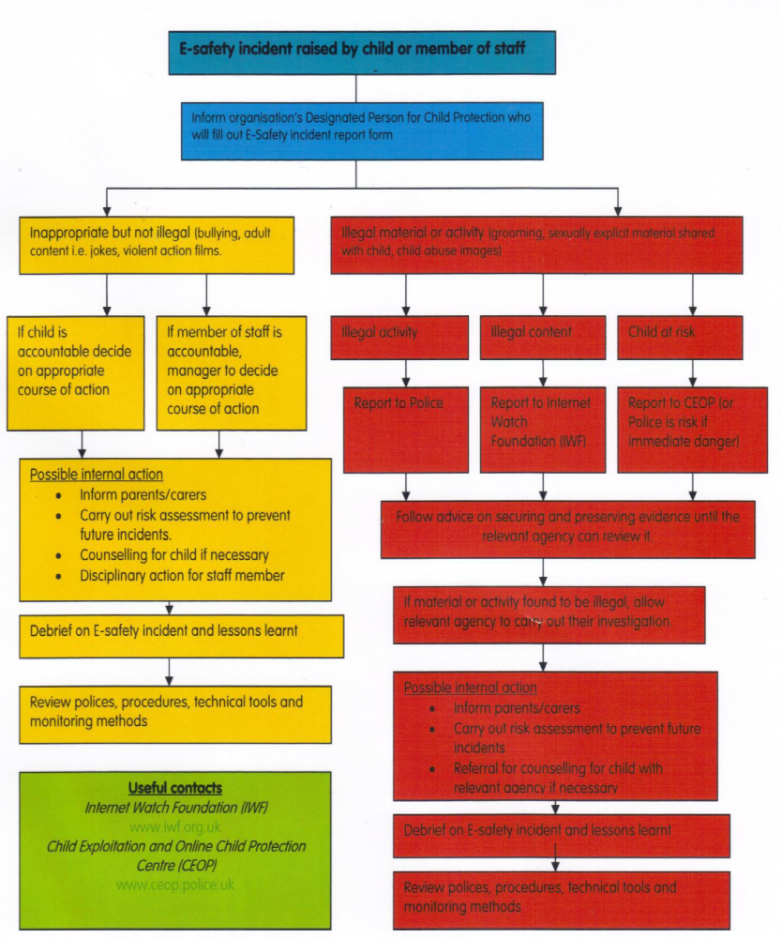

Birchfield Independent Girls School undertakes the following:

- Pupil instruction regarding responsible and safe use precedes internet access
- E–safety training is part of the transition programme across the key stages
- E-safety rules will be on display accessible to read.
- Safe and responsible use of the internet and technology is reinforced in ICT lessons.

E-Safety Contacts and References

- CEOP (Child Exploitation and Online Protection Centre): www.ceop.police.uk

- Childline: www.childline.org.uk

- Childnet: www.childnet.com

- Click Clever Click Safe Campaign: http://clickcleverclicksafe.direct.gov.uk

- Cybermentors: www.cybermentors.org.uk

- Digizen: www.digizen.org.uk

- Internet Watch Foundation (IWF): www.iwf.org.uk

- Kidsmart: www.kidsmart.org.uk

- Teach Today: http://en.teachtoday.eu

- Think U Know website: www.thinkuknow.co.uk

- Virtual Global Taskforce — Report Abuse: www.virtualglobaltaskforce.com

- Orange Education: www.orange.co.uk/education

- Safe: www.safesocialnetworking.org

Parental Agreement

As a parent / guardian, I have read the above policy for my child’s access to the internet and use of the school computer network. I recognise the fact that although the school uses a filtered Internet service and that the school will only allow pupil access to the Internet with their teacher’s supervision or supervision on another member of staff. Therefore, I will not hold staff responsible for materials that my child views or engages in because of using the Internet through facilities outside of school. I take full responsibility of how my child uses the Internet outside school.

Signature of parent/guardian: _____________________ Date: __________

Print Name____________________________

Rules for Responsible Internet and Computer Use
Pupil Acceptable Use Agreement Form

Please complete the sections below to show that you have read, understood, and agree to the rules included in the Acceptable Use Agreement. If you do not sign and return this agreement, access will not be granted to school ICT systems.

The school has installed computers with Internet access to help our learning. These rules will help to keep you safe and be fair to others. I understand that I must use school ICT systems in a responsible way, to ensure that there is no risk to my safety or to the safety and security of the ICT systems and other users.
For my own personal safety:
- I understand that the school will monitor my use of the ICT systems, email and other digital communications.

- I will treat my username and password like my toothbrush – I will not share it, nor will I try to use any other person’s username and password.

- I will be aware of “stranger danger” when I am communicating online.

- I will immediately report any damage or faults involving equipment or software; however this may have happened.

- I understand that everyone has equal rights to use technology as a resource.

- I understand that the school ICT systems are primarily intended for educational use and that I will not use the systems for personal or recreational use.

- I will not use the school ICT systems for online gaming and online gambling, shopping, file sharing, or video broadcasting (e.g. YouTube).
25
- I will respect others’ work and property and will not access, copy, remove or otherwise alter any other user’s files, without the owner’s knowledge and permission.

- I will be polite and responsible when I communicate with others, I will not use strong, aggressive, or inappropriate language and I appreciate that others may have different opinions.

- I will not install or attempt to install programmes of any type on a machine, or store programmes on a computer, nor will I try to alter computer settings.

- I will ensure that I have permission to use the original work of others in my own work.

- Where work is protected by copyright, I will not try to download copies

- When I am using the internet to find information, I will take care to check that the information that I access is accurate, as I understand that the work of others may not be truthful and may be a deliberate attempt to mislead me.

- I will not open any attachments to emails, unless I know and trust the person / organisation who sent the email, due to the risk of the attachment containing viruses or other harmful programmes.

- I will not use chat and social networking sites at all times in school.

- I will not access other people’s work without their permission
- I will ask permission before installing or loading software, shareware, or freeware
- I will not violate copyright laws or license agreements
- I will use the computers for schoolwork and homework
- I will not bring or use disks from home without permission
- I will not play games over the Internet during school time
- I will ask permission from a member of staff before using the Internet
- I will not view, send, or display offensive materials
- I will not waste limited resources such as disk space or printing ink and paper
- I will ask permission before printing documents in colour
- I will not give my home address, phone number or full name to anyone over the Internet
- I will only enter an Internet chat room with my parent or teacher’s permission
- I will not arrange to meet anyone without my parent or teacher’s permission
- I will notify an adult immediately if I encounter material or messages that make me feel uncomfortable
- I will not access the school computers and Internet without the permission and supervision of staff.

I understand that I am responsible for my actions, both in and out of school:

- I understand that the school also has the right to take action against me if I am involved in incidents of inappropriate behaviour, that are covered in this agreement, when I am out of school and where they involve my membership of the school community (examples would be cyber-bullying, use of images or personal information).

- I understand that if I fail to comply with this Acceptable Use Policy Agreement, I will be subject to disciplinary action. This may include loss of access to the school network / internet, detentions, suspensions, contact with parents and in the event of illegal activities involvement of the police.

I have read and understand the above and agree to follow these guidelines when:

- I use the school ICT systems and equipment (both in and out of school)

- I use my own equipment in school (when allowed) e.g. mobile phones, personal devices, tablets and cameras etc.

- I use my own equipment out of school in a way that is related to me being a member of this school e.g. communicating with other members of the school, accessing school email, website etc.

Name of Pupil

Class

Signed

Date

This document was produced on May 2023 and is due to be reviewed May 2024.

Signed (Chair)…………………………………… Date…………………………………

Print Name……………………………………….. Date of next review…………………

Head Teacher……………………………………..

Appendix

Letter to Parents – Invitation to attend Internet Safety Training Session

BIRCHFIELD INDEPENDENT GIRLS SCHOOL
BEACON HOUSE, 30 BEACON HILL,
ASTON, BIRMINGHAM B6 6JU
Tel: 0121 327 7707
E-mail: admin@bigs.bham.sch.uk
EST: 1990 Reg. Charity no: 1053283
Date:
Dear Parents,
Assalamu Alaykum,
I am writing to inform you that the school will be organising an Internet Safety training session after school and you are encouraged to attend. We all aware of the benefits the Internet, however, it is equally important that you are well informed about its dangers, especially when your child may be using it daily to complete homework. We are all open to the harms of the internet and therefore the school are offering you an opportunity to become acquainted about the ‘keep safe’ of Internet usage.
The training day will be held on……………………………………………. From…………..pm until ………….pm.
Please complete the slip below to confirm your attendance, and return it as soon as possible. I hope you will be able to attend. May Allaah reward you abundantly.
Yours sincerely,
Mrs R. Mogra
Headteacher
Internet Safety Training Session
I, ……………………. (parent of………………………, class……………) will be attending the after-school training session.
Or,
I,…………………… (parent of…………………………., class………….) am unable to attend the training session, however, I am interested to attend at a later date.

